Project 2

DESCRIPTION

Background

Mike Goodman, the head of Product Management of a retail products company, is responsible for determining which products his company should continue to offer for sale and which products should be discontinued from the company’s product catalog.

Objective

To build a dashboard that will present monthly sales performance by product segment and product category to help client identifying the segments and categories that have met or exceeded their sales targets, as well as those that have not met their sales targets.

Domain: Ecommerce

Analysis Tasks

1. Use the Saved Sample – Superstore dataset.
   * Two data sets were uploaded into the tableau environment.
2. Create a bullet chart with Category and Segment dimensions and Sales measures.
   * Here, first I blended the data in sheet1 using common fields which are “Category”, “Order date” and “Segment”. Then, two measures one from primary data source as Sales and sales target from secondary data source were used to make bullet chart.
3. Blend the data with the Saved Sample - Sales Target data set to bring in the Sales Target measure.
   * Data blending was performed as described in step 2 using provided two different data sources.
4. Color code the chart to identify Categories and Segments that are above or below target.
   * Color code was applied using created calculated filed from analysis tab. Then, equation was written in a way that if sales are below target color as “red” and if sales were above target “green color” was chosen.
5. Add the year of sales to the view to identify trends and outliers.
   * Done
6. Add a filter so that the user can select one, more than one, or all years.
   * Filter was applied using order date by dragging it into the filter field and all years were chosen for display.
7. Create a dashboard with this view.
   * 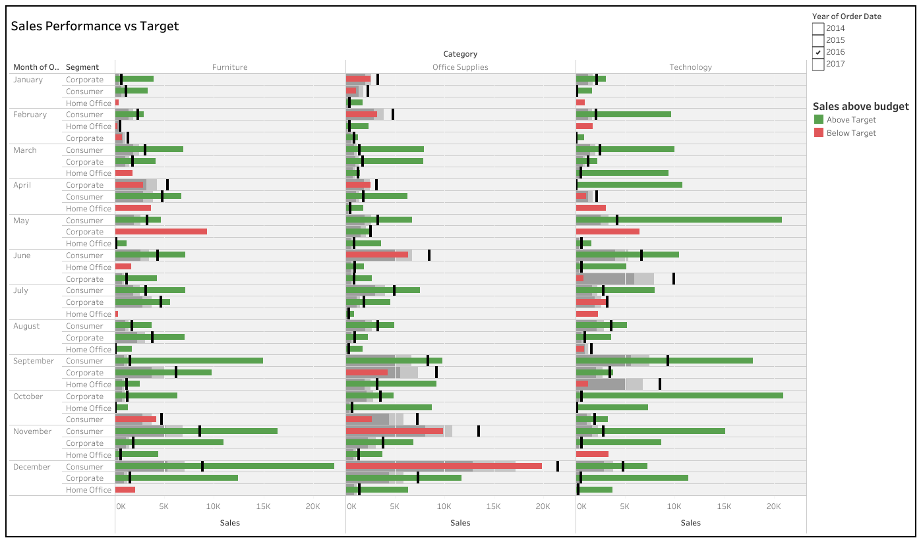Dash board was created using dashboard panel as shown below